Creating production pipeline

Step 1.

Click on Production ----> New Item ----> select pipeline project

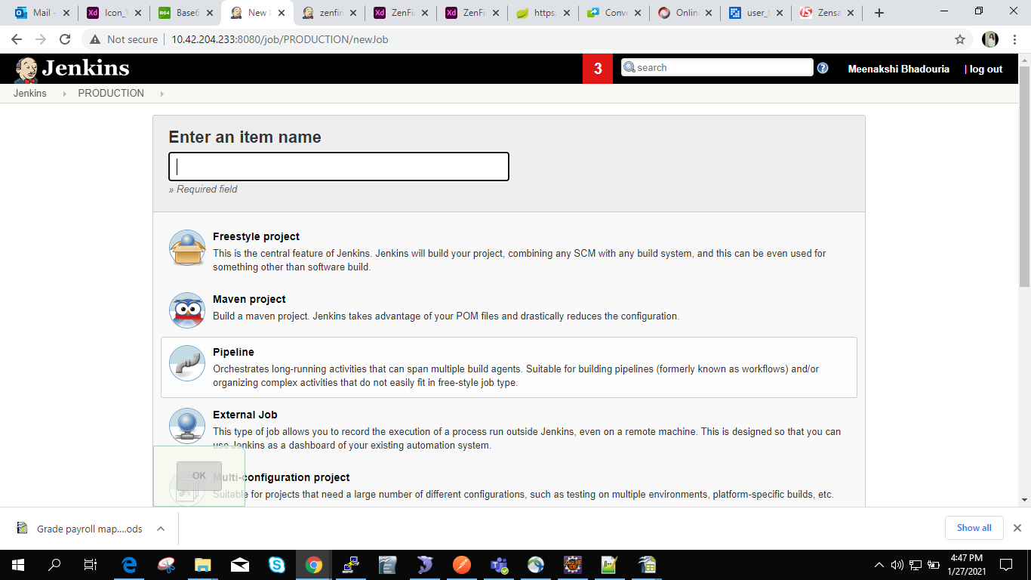

Step 2.

click on Configure then

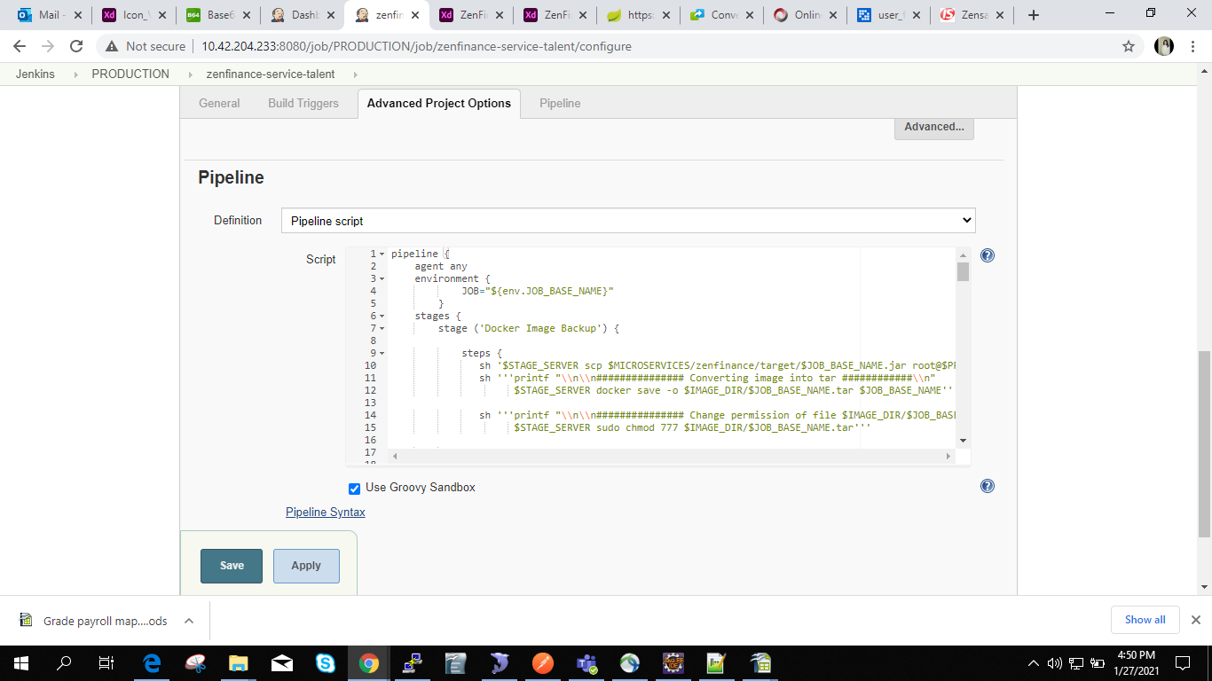

pipeline {
agent any
environment {
JOB="${env.JOB_BASE_NAME}"
}
stages {
stage ('Docker Image Backup') {

steps {
sh '$STAGE_SERVER scp $MICROSERVICES/zenfinance/target/$JOB_BASE_NAME.jar root@$PROD:$JAR_BACKUP_DIR/$JOB_BASE_NAME/${JOB_BASE_NAME}-${BUILD_TIMESTAMP}.jar'
sh '''printf "\\n\\n############### Converting image into tar ############\\n"
$STAGE_SERVER docker save -o $IMAGE_DIR/$JOB_BASE_NAME.tar $JOB_BASE_NAME'''

sh '''printf "\\n\\n############### Change permission of file $IMAGE_DIR/$JOB_BASE_NAME.tar ############\\n"
$STAGE_SERVER sudo chmod 777 $IMAGE_DIR/$JOB_BASE_NAME.tar'''

}
}

stage ('Copying image into production') {

steps {
sh '''printf "\\n\\n############### Coping image $JOB_BASE_NAME into production server $PROD_IMAGE_DIR ############\\n"
$STAGE_SERVER scp $IMAGE_DIR/$JOB_BASE_NAME.tar root@10.42.204.231:$PROD_IMAGE_DIR/'''

sh '''printf "\\n\\n############### Coping image $JOB_BASE_NAME into production server $PROD2 $PROD_IMAGE_DIR ############\\n"
$STAGE_SERVER scp $IMAGE_DIR/$JOB_BASE_NAME.tar $PROD2:$PROD_IMAGE_DIR/'''

sh '''printf "\\n\\n############### Coping image $JOB_BASE_NAME into production server $PROD3 $PROD_IMAGE_DIR ############\\n"
$STAGE_SERVER scp $IMAGE_DIR/$JOB_BASE_NAME.tar $PROD3:$PROD_IMAGE_DIR/'''

sh '''printf "\\n\\n############### Coping image $JOB_BASE_NAME into production server $PROD4 $PROD_IMAGE_DIR ############\\n"
$STAGE_SERVER scp $IMAGE_DIR/$JOB_BASE_NAME.tar $PROD4:$PROD_IMAGE_DIR/'''

sh '''printf "\\n\\n############### Coping image $JOB_BASE_NAME into production server $PROD5 $PROD_IMAGE_DIR ############\\n"
$STAGE_SERVER scp $IMAGE_DIR/$JOB_BASE_NAME.tar $PROD5:$PROD_IMAGE_DIR/'''

sh '''if $PROD_SERVER docker ps | grep " $JOB_BASE_NAME"; then
printf "\\n\\n########### Stoping existing $JOB_BASE_NAME ###############\\n"
$PROD_SERVER docker stop $JOB_BASE_NAME
else
printf "\\n\\n########### Container $JOB_BASE_NAME is not running ###############\\n"
fi'''

sh '''if ssh $PROD2 sudo docker ps | grep " $JOB_BASE_NAME"; then
printf "\\n\\n########### Stoping existing $JOB_BASE_NAME ###############\\n"
ssh $PROD2 sudo docker stop $JOB_BASE_NAME
else
printf "\\n\\n########### Container $JOB_BASE_NAME is not running ###############\\n"
fi'''

sh '''if ssh $PROD3 sudo docker ps | grep " $JOB_BASE_NAME"; then
printf "\\n\\n########### Stoping existing $JOB_BASE_NAME ###############\\n"
ssh $PROD3 sudo docker stop $JOB_BASE_NAME
else
printf "\\n\\n########### Container $JOB_BASE_NAME is not running ###############\\n"
fi'''

sh '''if ssh $PROD4 sudo docker ps | grep " $JOB_BASE_NAME"; then
printf "\\n\\n########### Stoping existing $JOB_BASE_NAME ###############\\n"
ssh $PROD4 sudo docker stop $JOB_BASE_NAME
else
printf "\\n\\n########### Container $JOB_BASE_NAME is not running ###############\\n"
fi'''

sh '''if ssh $PROD5 sudo docker ps | grep " $JOB_BASE_NAME"; then
printf "\\n\\n########### Stoping existing $JOB_BASE_NAME ###############\\n"
ssh $PROD5 sudo docker stop $JOB_BASE_NAME
else
printf "\\n\\n########### Container $JOB_BASE_NAME is not running ###############\\n"
fi'''

}
}
stage ('Loading image into docker') {

steps {
sh '''printf "\\n\\n########### load image $JOB_BASE_NAME from tar file $PROD_IMAGE_DIR/$JOB_BASE_NAME.tar ###############\\n"
$PROD_SERVER docker load -i $PROD_IMAGE_DIR/$JOB_BASE_NAME.tar'''

sh '''printf "\\n\\n########### load image $JOB_BASE_NAME from tar file $PROD_IMAGE_DIR/$JOB_BASE_NAME.tar on $PROD2 ###############\\n"
ssh $PROD2 sudo docker load -i $PROD_IMAGE_DIR/$JOB_BASE_NAME.tar'''

sh '''printf "\\n\\n########### load image $JOB_BASE_NAME from tar file $PROD_IMAGE_DIR/$JOB_BASE_NAME.tar on $PROD3 ###############\\n"
ssh $PROD3 sudo docker load -i $PROD_IMAGE_DIR/$JOB_BASE_NAME.tar'''

sh '''printf "\\n\\n########### load image $JOB_BASE_NAME from tar file $PROD_IMAGE_DIR/$JOB_BASE_NAME.tar on $PROD4 ###############\\n"
ssh $PROD4 sudo docker load -i $PROD_IMAGE_DIR/$JOB_BASE_NAME.tar'''

sh '''printf "\\n\\n########### load image $JOB_BASE_NAME from tar file $PROD_IMAGE_DIR/$JOB_BASE_NAME.tar on $PROD5 ###############\\n"
ssh $PROD5 sudo docker load -i $PROD_IMAGE_DIR/$JOB_BASE_NAME.tar'''

}
}
stage ('Start docker Image') {

steps {

sh '''printf "\\n\\n########### Running container $JOB_BASE_NAME ###############\\n"
$PROD_SERVER docker run \
--env-file /usr/local/microservices/set.env \
-d -e "TZ=Asia/Kolkata" -v /upload:/upload --rm=true --name=$JOB_BASE_NAME --publish=69:69 $JOB_BASE_NAME:latest'''

sh '''printf "\\n\\n########### Running container $JOB_BASE_NAME on $PROD2 ###############\\n"
ssh $PROD2 sudo docker run \
--env-file /usr/local/microservices/set.env \
-d -e "TZ=Asia/Kolkata" -v /upload:/upload --rm=true --name=$JOB_BASE_NAME --publish=69:69 $JOB_BASE_NAME:latest'''

sh '''printf "\\n\\n########### Running container $JOB_BASE_NAME on $PROD3 ###############\\n"
ssh $PROD3 sudo docker run \
--env-file /usr/local/microservices/set.env \
-d -e "TZ=Asia/Kolkata" -v /upload:/upload --rm=true --name=$JOB_BASE_NAME --publish=69:69 $JOB_BASE_NAME:latest'''

sh '''printf "\\n\\n########### Running container $JOB_BASE_NAME on $PROD4 ###############\\n"
ssh $PROD4 sudo docker run \
--env-file /usr/local/microservices/set.env \
-d -e "TZ=Asia/Kolkata" -v /upload:/upload --rm=true --name=$JOB_BASE_NAME --publish=69:69 $JOB_BASE_NAME:latest'''

sh '''printf "\\n\\n########### Running container $JOB_BASE_NAME on $PROD5 ###############\\n"
ssh $PROD5 sudo docker run \
--env-file /usr/local/microservices/set.env \
-d -e "TZ=Asia/Kolkata" -v /upload:/upload --rm=true --name=$JOB_BASE_NAME --publish=69:69 $JOB_BASE_NAME:latest'''

}
}
stage ('zenfinance-service-talent deployed successfully') {

steps {
sh '''printf "\\n\\n########### check log file $LOG_FILE_DIR/$JOB_BASE_NAME.log for $JOB_BASE_NAME #################\\n"
$PROD_SERVER "docker logs $JOB_BASE_NAME --follow>>$DOCKER_LOGS/$JOB_BASE_NAME.log 2>&1 &"'''

sh '''printf "\\n\\n########### check log file $LOG_FILE_DIR/$JOB_BASE_NAME #################\\n"
ssh $PROD2 "sudo docker logs $JOB_BASE_NAME --follow>>$DOCKER_LOGS/${JOB_BASE_NAME}/${JOB_BASE_NAME}_${BUILD_TIMESTAMP}.log 2>&1 &"'''

sh '''printf "\\n\\n########### check log file $LOG_FILE_DIR/$JOB_BASE_NAME #################\\n"
ssh $PROD3 "sudo docker logs $JOB_BASE_NAME --follow>>$DOCKER_LOGS/${JOB_BASE_NAME}/${JOB_BASE_NAME}_${BUILD_TIMESTAMP}.log 2>&1 &"'''

sh '''printf "\\n\\n########### check log file $LOG_FILE_DIR/$JOB_BASE_NAME #################\\n"
ssh $PROD4 "sudo docker logs $JOB_BASE_NAME --follow>>$DOCKER_LOGS/${JOB_BASE_NAME}/${JOB_BASE_NAME}_${BUILD_TIMESTAMP}.log 2>&1 &"'''

sh '''printf "\\n\\n########### check log file $LOG_FILE_DIR/$JOB_BASE_NAME #################\\n"
ssh $PROD5 "sudo docker logs $JOB_BASE_NAME --follow>>$DOCKER_LOGS/${JOB_BASE_NAME}/${JOB_BASE_NAME}_${BUILD_TIMESTAMP}.log 2>&1 &"'''

}

}

}
}

Step 3.

set.env ---- set all environment variables in set.env
create folder like zenfinance-service-talent in 231 server usr/local/microservices/Jarbackup
create folder /usr/local/microservices/logs/dockerlogs/ zenfinance-service-talent in 85, 86, 87 ,88 servers

